Interactive Notebook Guidelines
What is the purpose of the Interactive Notebook?
The purpose of the Interactive Civics Notebook is to enable you to be a creative, independent thinker and writer. Interactive notebooks will be used for class notes as well as for other activities in which you will be asked to express your own ideas and process the information presented in class.
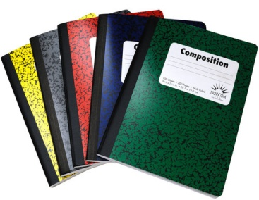
What materials do I need?
• Composition notebook
• Glue stick and scissors
• Highlighters
What goes in my notebook?
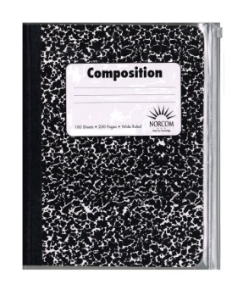
EVERYTHING we do in class. We will use graphically organized visuals to help you take notes, organizing them so that key ideas are clear and supported by examples from class activities, discussion, or reading assignments. Your notebook will also be used for a variety of different activities to preview learning and process new content to demonstrate understanding. This is where you will record and express all of your ideas. The following should always be included in the front of your notebook:
- These guidelines (Signed by you and a parent/guardian)
- Cover (Decorated by Theme)
- Title Page for each unit
- Table of Contents
- Goal Sheets
- Analysis Step Sheets
What are the daily expectations for the notebook?
All students must keep a complete, neat notebook that produces quality work, and has taken the time to consistently extend learning beyond classroom assignments. Notebooks will be graded on thoroughness, quality, and organization. Your notebook should be NEAT! Each entry should be title and dated. Notebooks will be checked regularly for completeness. All class notes and notebook assignments should be included, even for days you were absent. Your table of contents must be updated and every page must be labeled and numbered.
What happens if I am absent?
If you are absent, it is your responsibility to obtain notebook assignments from a classmate or from the Interactive Teacher Notebook.
Share this handout with your parent or guardian. When both of you have read this information, please sign your names below.
Student Signature ___________________________________ Parent Signature _______________________
Adapted from: Getting Started with Interactive Notebooks by TCI http://www.teachtci.com/pdf/webinar_handouts/Interactive_Student_Notebook_Getting_Started.pdf

